**Final Project: INFO 7390 Advances in Data Science**

**STOCK PRICE FORECASTING**



**TEAM 11**

Aditya Pawar

Dhairya Jaiswal

Ranga Chari

# OVERVIEW

Stock price forecasting is one of the most important area in todays data science field as it helps in determining the future value of a companies stock or other financial instrument traded on exchange. Depending on how well the prediction algorithms work it could yield a significant profit for the public/investors.

# 

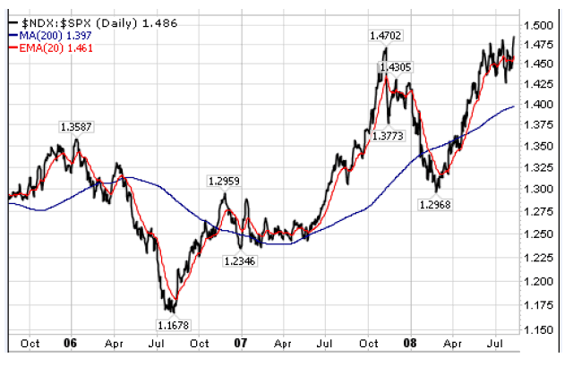

**GOALS**

* To provide insightful decision-making trends for public which would be profitable in near as well as the long run.
* Changing demands of stock value during the day.
* Factors affecting the high and low value of stock prices.
* Date, Open, High, Low, Close, Volume, OpenInt
* Other conditions that may influence the stock pricing.
* Offering an interactive UI that lets the user read the description of a particular company’s data and also provides them future prediction values on a daily and weekly basis.
* Predict various high and low values as per day trends because of various influential trading factors(Like companies acquiring or merging with other companies).

**USE CASES**

* Giving foresight to investors to make the right decisions and avoid making a loss.
* Knowing upfront highs and lows in stock trends.
* Up-trends, down-trends sideway moves of the market are some of the main features we plan to predict.

# DATA

* **STOCK DATA** - <https://www.kaggle.com/borismarjanovic/price-volume-data-for-all-us-stocks-etfs/data>
* The data starts from 1985 and ends 2017

**PROCESS OUTLINE**

* Data Preprocessing, Data Cleaning, handling missing values
* Exploratory Data Analysis
* Study of time series approach and select the best models for prediction.
* Study of Unsupervised approaches like logistic regression, ARIMA(Auto Regressive Intensive Moving Average) for prediction.
* Design of a pipeline and system to implement this approach and discussion on the system’s capabilities
* Deploy the Model on Azure/AWS or Google Cloud Computing Platform
* Build a web application to demonstrate the prediction results and detailed analysis of selected stock value.

# 

## **DEPLOYMENT DETAILS:**

1. Language: Python
2. Pipeline: Airflow
3. Container: Docker
4. Cloud Tools/Platforms: Microsoft Azure Machine Learning Studio,AWS (Amazon WEb Services) EC2
5. Tools for Analysis: Microsoft Azure Visual Studio
6. Other Considerations: Google Cloud Platform